Title: Day 5 – IoT Smart Home Dashboard

Date: 14 Sept 2025
Name: Nihar Ashraf

Introduction:
On Day-4, we successfully simulated device communication using socket programming, allowing the IoT Smart Home Dashboard to control devices (TV, AC, Fan, Light, RoboVac & Mop). However, device status updates were limited, and database tracking of state changes was incomplete.
Day-5 focused on improving the data persistence layer and system robustness by:
- Enhancing the database schema.
- Implementing status tracking with timestamps.
- Integrating telemetry recording.
- Validating ownership and error handling.

Activities Performed:
- Database Enhancements:
Added a new column last_updated in the gadgets table to record when a gadget’s status was last changed.

- Code Enhancements:
a) Gadget.java
- Added ownerId field with getter/setter.
- Ensured constructors supported both with and without ownerId.
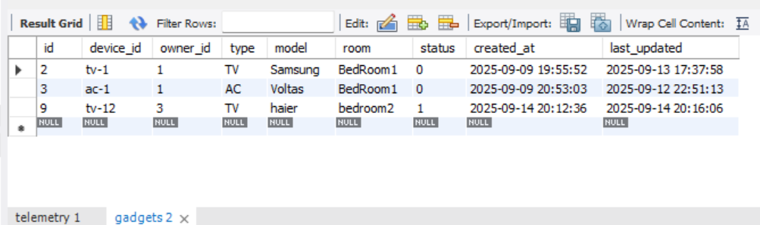
b) GadgetDAO.java
- Updated findByDeviceId() to fetch and return the ownerId.
- Updated updateStatus() to also update the last_updated timestamp.
- Ownership check enforced in deleteByDeviceId().

c) DeviceClient.java
- Added connection and read timeouts to simulate device unreachable scenarios.
- Added helper sendSetStatusCommand(boolean on) for simpler commands.
- Clear console messages:
- "Device confirmed status change"
- "Device unreachable (localhost:port)"

d) UpdateGadgetStatus.java
- Centralized logic for:
  - Ownership validation.
  - Device communication.
  - DB update and telemetry write.
- Clear separation of successful vs. unreachable device cases.

e) JavaApp.java
- Menu option 5 (Change Gadget Status) now uses UpdateGadgetStatus.
- Console feedback clarified: switched ON/OFF successful vs. device unreachable warning.
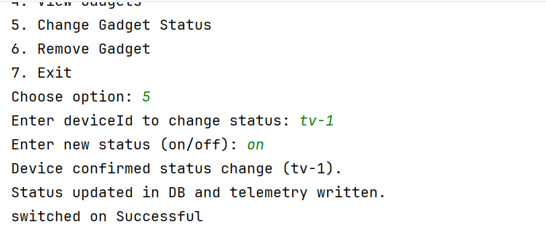
f) TelemetryService.java
- Implemented writeTelemetry(deviceId, metric, value) to log status changes.
- Added new telemetry table to database:
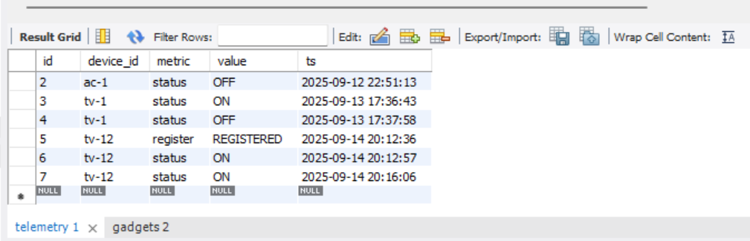

Testing and Results
- Device Reachable
- Started a device simulator (e.g., tv-1 on port 9001).
- Changed gadget status via JavaApp.
- Console output: “Device confirmed status change”.
- Database updated status and last_updated.

- Device Unreachable
- Stopped the device simulator.
- Changed gadget status again.
- Console output: “Device unreachable … Warning: updating DB anyway”.
- Database still updated status and last_updated.
- Telemetry recorded event in telemetry table.

- Ownership Validation
- Verified only the logged-in user can update/delete their gadgets.
- Attempts by other users were denied.

- Telemetry Logging
- Confirmed entries in the telemetry table for each ON/OFF operation.
Conclusion:
Day-5 achieved a major improvement in system reliability and tracking. The IoT Dashboard can now:
- Handle both reachable and unreachable device scenarios.
- Update gadget status consistently in the database.
- Maintain an accurate last updated timestamp for each gadget.
- Record a telemetry history of all ON/OFF actions.
- Enforce ownership validation for better security.
- These improvements bring the project closer to a realistic IoT solution, where every status change is logged and traceable.

